**Internship Report**

**Artificial Intelligence & Machine Learning**

**DLithe Consultancy Services Pvt. Ltd.**



**Internship Report**

**Trainee/Intern Name:** Akshatha G R

**Reg. no:** 4PM22MC001

**Period:** 6 Weeks

**Job Assignment:** Online Payment Fraud Detection

**Organization:** DLithe Consultancy Services Pvt. Ltd.

**Supervisor’s Name: Bhavana A S**

**Observations:**

Collection of data and pre-processing of data.

Model Selection and Evaluation of Model

Data visualization of types of payment

Visualization of correlation graph

Prediction of Accuracy among different models

Prediction of Percentage of fraud or not fraud transactions record present

**Submitted to**

Signature of Training Supervisor Signature of Co-ordinator

Date:27/11/2023 Date: 27/11/2023

**Letter of Transmittal**

To,

Program Co-ordinator

DLithe Consultancy services

Bengaluru

Dear Sir,

I am writing to submit my report on AI/ML Internship that I recently completed on Artificial Intelligence (AI) and Machine Learning (ML). The training program was an invaluable learning experience, and I am grateful for the opportunity to participate.

The training program covered various aspects of AI and ML, including basic concepts, algorithms, programming languages, and practical applications. I gained a comprehensive understanding of the role of AI and ML in modern technology and industry, and also gained hands-on experience with AI and ML tools and platforms. The training highlighted the potential of AI and ML to revolutionize various fields, including healthcare, finance, and manufacturing.

The report includes a detailed overview of the training program, including the topics covered, the learning objectives, and the outcomes achieved. It also provides observations and insights into the potential benefits and challenges of implementing AI and ML solutions in different fields.

I believe that the knowledge and skills that I acquired during the training program will be valuable to our organization. AI and ML are rapidly becoming more ubiquitous in various industries, and the ability to work with AI and ML tools and platforms will be increasingly important for our organization's success.

I hope that the report provides useful insights into the benefits of on-job training and the potential of AI and ML.

Sincerely,

Name: Rashmi M

Reg. no: 1DS22MC075

**Table of Contents**

1. Introduction
   1. Background
   2. Literature Survey

2. Project Overview

* 1. Problem statement

3. System requirements

3.1 Hardware requirements

3.2 Software requirements

4. Methodology

4.1 Tools and Technologies used

5. System Design

5.1 Architecture

6. Implementation

6.1 Dataset Details

6.2 Code

7. Results

8. Applications

8.1 Applications of AI/ML

9. Training Experience

10. Observations

11. Key Learnings

11.1 Challenges

12. Conclusion

1. **INTRODUCTION**

Artificial Intelligence and Machine Learning are two of the most popular and rapidly growing fields in computer science. They are transforming the way we live, work, and interact with technology. The purpose of this report is to provide an overview of my Internship Training experience on Artificial Intelligence and Machine Learning, and to describe the various concepts and techniques that I learned during the training.

Machine learning (ML) is a type of artificial intelligence (AI) that allows software applications to become more accurate at predicting outcomes without being explicitly programmed to do so. Machine learning algorithms use historical data as input to predict new output values. It allows the user to feed a computer algorithm an immense amount of data and have the computer analyse and make data-driven recommendations and decisions based on only the input data. Machine learning algorithms are used in a wide variety of applications, such as in medicine, email filtering, speech recognition, and computer vision, where it is difficult or unfeasible to develop conventional algorithms to perform the needed tasks.

The advent of online transactions has revolutionized the way we conduct financial activities, offering convenience and accessibility. However, with this digital transformation comes the escalating threat of online payment fraud. Unauthorized transactions, identity theft, and fraudulent activities pose significant challenges to the security and integrity of online payment systems.

This project delves into the realm of machine learning to address the pressing need for robust fraud detection mechanisms. The objective is to leverage advanced algorithms, including logistic regression, decision tree, random forest, and gradient boosting, to analyse a dataset containing transaction details. By scrutinizing patterns and anomalies within the data, our goal is to develop models capable of accurately identifying and flagging potentially fraudulent transactions.

As the digital landscape evolves, the traditional rule-based approaches to fraud detection prove inadequate in dealing with the complexity and sophistication of modern fraud techniques. Machine learning offers a promising avenue, allowing us to harness the power of algorithms that can adapt and learn from patterns in vast datasets.

Through this project, we aim to contribute to the ongoing efforts to secure online payment systems, providing a proactive defence against the evolving tactics of fraudsters. The exploration of multiple machine learning algorithms enables a comprehensive evaluation of their efficacy in distinguishing legitimate transactions from fraudulent ones. The results of this endeavour are anticipated to enhance the resilience of online payment platforms, ensuring a secure and trustworthy digital financial environment.

* 1. **BACKGROUND**

The proliferation of digital transactions has ushered in a new era of convenience and efficiency in financial activities. However, the flip side of this technological advancement is the escalating threat of online payment fraud. Criminal’s adept at exploiting vulnerabilities in digital systems continually devise sophisticated methods to compromise the security of online transactions.

Traditional approaches to fraud detection, often reliant on rule-based systems, struggle to keep pace with the ever-evolving tactics employed by fraudsters. As a result, there is a growing imperative to adopt more adaptive and intelligent solutions. Machine learning, with its ability to discern intricate patterns within vast datasets, emerges as a potent ally in the battle against online payment fraud.

The landscape of online fraud is dynamic, with perpetrators employing tactics ranging from identity theft to complex financial manipulations. Machine learning models offer the promise of continuous learning and adaptation, making them well-suited to identify anomalies and patterns indicative of fraudulent activities.

This project is grounded in the recognition that safeguarding online payment systems requires a proactive and technologically advanced approach. By leveraging machine learning algorithms, including logistic regression, decision tree, random forest, and gradient boosting, we aim to fortify the defences of digital financial platforms. The analysis of a carefully curated dataset provides a practical foundation for training and evaluating these models, offering insights into their effectiveness in distinguishing between legitimate and fraudulent transactions.

In navigating the landscape of online payment fraud, this project stands as a strategic response to the need for cutting-edge, intelligent solutions that can evolve alongside the dynamic nature of cyber threats. Through this endeavour, we contribute to the ongoing discourse on securing digital financial ecosystems, fostering trust, and ensuring the integrity of online transactions in an era where technology and risk walk hand in hand.

* 1. **LITERATURE SURVEY**
* Title: "A Survey of Fraud Detection Techniques in E-payment Systems"  
  Authors: Ondrej Krejcar, Petr Gajdos, and Ondrej Rysavy  
  Year: 2019
* Title: "Fraud Detection in Online Payment Systems Using Supervised Machine Learning Algorithm”

Authors: Christian J. Walters and Gary B. Wills  
Year: 2018

* Title: "Feature Selection and Ensemble Learning for Credit Card Fraud Detection"  
  Authors: Hua, F., & Li, J.

Year: 2016

1. **PROJECT OVERVIEW**

The Internship Training program on Artificial Intelligence and Machine Learning that I participated in was conducted by a technology company. The program was designed to provide a comprehensive overview of the latest advancements in the field of AI and ML, and to equip participants with the skills and knowledge required to build intelligent systems and applications.

The training program consisted of practical hands-on sessions. The lectures covered a wide range of topics, including the fundamentals of AI and ML, various techniques and algorithms used in machine learning, and the latest developments in deep learning and neural networks. The practical sessions involved working on various projects and implementing machine learning algorithms on real-world datasets.

* 1. **PROBLEM STATEMENT**

The proliferation of online transactions has brought unparalleled convenience, but it has also exposed users and financial institutions to the ever-present threat of online payment fraud. Traditional fraud detection systems, often rule-based and static, struggle to keep pace with the sophistication and adaptability of modern fraud techniques. Consequently, the financial ecosystem faces a critical need for more advanced and adaptive solutions.

The core problem addressed by this project is the accurate identification and prevention of online payment fraud. The challenges lie in distinguishing between legitimate transactions and fraudulent activities that continually evolve to exploit vulnerabilities in digital systems. The limitations of existing methods necessitate a shift towards leveraging machine learning algorithms to discern intricate patterns and anomalies within vast datasets.

Key aspects of the problem include:

1. **Dynamic Fraud Tactics:** Fraudsters employ ever-changing tactics, including identity theft, account takeover, and intricate financial manipulations, making it challenging for static rule-based systems to adapt swiftly.

2. **False Positives and Negatives:** Striking the right balance between minimizing false positives (flagging legitimate transactions as fraudulent) and false negatives (missing actual fraudulent transactions) is crucial for the effectiveness of any fraud detection system.

3. **Continuous Adaptation:** Fraud patterns evolve over time, requiring a solution that can continuously learn and adapt to new fraud techniques without frequent manual interventions.

4. **User Trust and Experience:** Implementing effective fraud detection is essential, but it should not compromise the seamless experience of genuine users. Striking a balance between security and user experience poses an additional challenge.

Addressing these aspects constitutes the heart of the problem statement, and the project endeavours to contribute an intelligent, adaptive, and efficient solution to enhance the security of online payment systems.

1. **SYSTEM REQUIREMENTS**

A software requirements specification (SRS) is a document that describes what the software will do and how it will be expected to perform. It also describes the functionality the product needs to fulfil all stakeholders (business, users) need. SRS not only lists the requirements of a system that also has a description of its major features. These recommendations extend the IEEE standards. The recommendations would form the basis for providing clear visibility of the product to be developed serving as baseline for execution of a contract between client and the developer.

A system requirement is one of the main steps involved in the development process. It follows a resource analysis phase that is the task to determine what a particular software product does. The focus in this stage is one of the users of the system and not the system solutions. The result of the requirement specification document states the intention of the software, properties, and constraints of the desired system.

SRS constitutes the agreement between clients and developers regarding the contents of the software product that is going to be developed. SRS should accurately and completely represent the system requirements as it makes a huge contribution to the overall project plan.

A Requirement Specification is a collection of the set of all requirements that are to be imposed on the design and verification of the product. The specification also contains other related information necessary for the design, verification, and maintenance of the product

* 1. **HARDWARE REQUIREMENTS**

1. **Processing Power:** A multicore processor with sufficient computational power to handle the training of machine learning models. A quad-core or higher processor is recommended for efficient model training.

2. **Memory (RAM):** A minimum of 8 GB RAM is recommended for handling large datasets and training complex machine learning models. Higher RAM capacity will enhance performance, especially when dealing with extensive feature sets.

* 1. **SOFTWARE REQUIREMENTS**

1. **Operating System:** A modern operating system such as Windows, macOS, or Linux that supports the required software and libraries for machine learning.
2. **Python Environment:** Install Python along with essential libraries for machine learning, such as NumPy, Pandas, Scikit-learn, and others. Utilize a virtual environment to manage dependencies effectively.
3. **Machine Learning Libraries:** Install machine learning libraries like TensorFlow or PyTorch for implementing deep learning models if applicable. Scikit-learn is essential for traditional machine learning algorithms.
4. **Integrated Development Environment (IDE):** Choose a suitable IDE for coding and experimentation, such as Jupyter Notebooks, Spyder, or Visual Studio Code.

1. **METHODOLOGY**

The methodology for this project involves a structured and systematic approach to leverage machine learning algorithms for online payment fraud detection. The process unfolds in several key stages:

1. **Data Collection:**

* The first step was to collect dataset from various sources like Kaggle, Google Scholar etc.
* We found the required dataset from Kaggle named Online Payment Fraud Detection.

1. **Data Preprocessing:**

* **Handling Missing Values:** Identify and address any missing values in the dataset to ensure the integrity of the data.
* **Encoding Categorical Variables:** Transform categorical variables into numerical format suitable for machine learning models.
* **Feature Scaling:** Standardize or normalize features to bring them to a similar scale, preventing any particular feature from dominating the model training.

1. **Model Selection:**

* **Logistic Regression:** A linear model suitable for binary classification tasks, such as fraud detection.
* **Decision Tree:** A tree-like model capable of capturing complex relationships within the data.
* **Random Forest:** An ensemble of decision trees, providing improved accuracy and robustness.
* **Gradient Boosting:** A boosting technique that builds models sequentially, focusing on the weaknesses of the previous ones.

1. **Data Splitting:**

* Divide the dataset into training and testing sets. The training set is used to train the machine learning models, while the testing set evaluates their performance on unseen data. We have split the data into 7:3 ratio that is 70% data for training and 30% for testing the data.

1. **Model Training and Evaluation:**

* Train each selected algorithm on the training set using historical transaction data.
* Evaluate the models on the testing set to measure their accuracy and performance.
* Utilize performance metrics such as accuracy, precision, recall, and F1 score to assess the effectiveness of each model.

1. **Comparative Analysis:**

* Conduct a comprehensive analysis to compare the performance of the selected machine learning algorithms.
* Identify strengths and weaknesses, and determine which algorithm(s) demonstrate superior fraud detection capabilities.

1. **Results Interpretation:**

* Interpret the results of the models, considering both their overall accuracy and their ability to correctly identify fraudulent transactions.
* Examine the false positive and false negative rates to understand the balance between precision and recall.

1. **Real-world Applicability:**

* Consider the practical implications of the models for real-world applications in online payment systems.
* Evaluate the feasibility of integrating the developed models into existing fraud detection mechanisms.

**4.1 TOOLS AND TECHNOLOGIES USED:**

During the project, I used various tools and technologies such as:

1. **Windows:** Windows is a graphical operating system developed by Microsoft. It allows users to view and store files, run the software, play games, watch videos, and provides a way to connect to the internet. It was released for both home computing and professional works. Microsoft introduced the first version as 1.0.
2. **Jupyter Notebook:** Jupyter Notebook was mainly used for creating and running the code. Jupyter Notebooks are a community standard for communicating and performing interactive computing. They are a document that blends computations, outputs, explanatory text, mathematics, images, and rich media representations of objects.
3. **Python:** Python was mainly used for data preprocessing, feature selection, and model training. Python is a computer programming language often used to build websites and software, automate tasks, and conduct data analysis. Python is a general-purpose language, meaning it can be used to create a variety of different programs and is not specialized for any specific problems. Python is a high-level, interpreted, general-purpose programming language. Its design philosophy emphasizes code readability with the use of significant indentation. Python is dynamically-typed and garbage-collected. It supports multiple programming paradigms, including structured, object-oriented, and functional programming. It is often described as a "batteries included" language due to its comprehensive standard library. Python consistently ranks as one of the most popular programming languages. Python is meant to be an easily readable language. Its formatting is visually uncluttered and often uses English keywords where other languages use punctuation. Unlike many other languages, it does not use curly brackets to delimit blocks, and semicolons after statements are allowed but rarely used. It has fewer syntactic exceptions and special cases than C or Pascal.
4. **Scikit-Learn:** Scikit-Learn was mainly used for model selection and model training. Scikit-learn (Sklearn) is the most useful and robust library for machine learning in Python. It provides a selection of efficient tools for machine learning and statistical modelling including classification, regression, clustering, and dimensionality reduction via a consistent interface in Python. This library, which is largely written in Python, is built upon NumPy, SciPy and Matplotlib.
5. **Numpy:** Numpy is a library for the python programming language, adding support for large, multi-dimensional arrays and matrices, along with a large collection of high-level mathematical functions to operate on these arrays. The ancestor of NumPy, Numeric, was originally created by Jim with contributions from several other developers. In 2005, Travis created NumPy by incorporating features of the competing Numarray into Numeric, with extensive modifications. NumPy is open-source software and has many contributors.
6. **Pandas:** Pandas is a software library written for the Python programming language for data manipulation and analysis. It offers data structures and operations for manipulating numerical tables and time series. It is free software released under the threeclause BSD license. Pandas is mainly used for data analysis and associated manipulation of tabular data in Data frames. Pandas allows importing data from various file formats such as comma-separated values, JSON, Parquet, SQL database tables or queries, and Microsoft Excel.
7. **Matplotlib:** Matplotlib was mainly used for data visualization. It is a plotting library for the Python programming language and its numerical mathematics extension NumPy. It provides an object-oriented API for embedding plots into applications using general-purpose GUI toolkits like Tkinter, wxPython, Qt, or GTK. There is also a procedural "pylab" interface based on a state machine (like OpenGL), designed to closely resemble that of MATLAB, though its use is discouraged.
8. **Seaborn:** Seaborn is a Python data visualization library based on matplotlib. It provides a highlevel interface for drawing attractive and informative statistical graphics. Seaborn is a library in Python predominantly used for making statistical graphics. Seaborn is a data visualization library built on top of matplotlib and closely integrated with pandas data structures in Python. Visualization is the central part of Seaborn which helps in exploration and understanding of data.

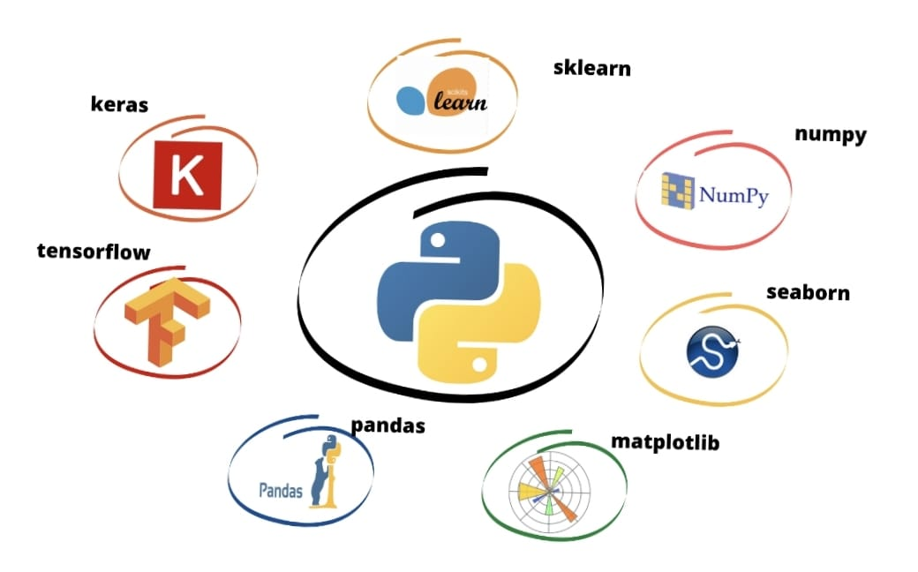

**Figure1:** Packages

1. **SYSTEM DESIGN**

Systems design is the process of defining the architecture, product design, modules, interfaces, and data for a system to satisfy specified requirements. Systems design could be seen as the application of systems theory to product development.

* 1. **ARCHITECTURE**

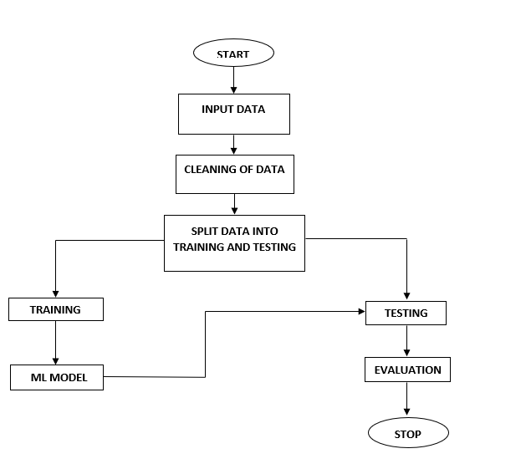

**Figure2:** System design of online payment fraud prediction

The system architecture gives an overview of the working of the system. The working of this system is described as follows:

Dataset collection is collecting data which contains transaction details. Attributes selection process selects the useful attributes for the prediction of fraud transaction. After identifying the available data resources, they are further selected, cleaned, made into the desired form. Different classification techniques as stated will be applied on preprocessed data to predict the accuracy of fraud prediction. Accuracy measure compares the accuracy of different classifiers.

1. **IMPLEMENTATION**

Implementation is the process of converting a or a revised system design into an operational one. The objective is to put the new or revised system that has been tested into operation while holding costs, risks, and peronal irritation to the minimum. A critical aspect or the implementation process is to ensure that there will be no disrupting the functioningor the organization. The best method for gaining control while implanting aany new system would be to use well plannned test for testing all new programs. Before production files are used to test live data, text files must be created on the old system, copied over to the new system, and used for the initial test of each program.

**6.1** **DATASET DETAILS**

This study's dataset for fraud prediction was obtained from a publicly accessible site. The data in this set pertains to fraud detection. When determining whether a transaction is at risk for a fraud, this dataset considers factors such as step, type, amount, nameOrig, oldbalanceOrig, newbalanceOrig, nameDest, oldbalanceDest, newbalanceDest, isFraud and isFlaggedFraud. Each entry in the data table provides essential information about the transaction details. There are totally 11 attributes used. The complete description of the attributes used in the work is given below:

1. **step:** Represents the timestamp or step in the process of the financial transactions.
2. **type:** Indicates the type of transaction (e.g., PAYMENT, TRANSFER, CASH_OUT, DEBIT).
3. **amount:** The amount of money involved in the transaction.
4. **nameOrig:** The name or identifier of the origin account.
5. **oldbalanceOrig:** The old balance of the origin account before the transaction.
6. **newbalanceOrig:** The new balance of the origin account after the transaction.
7. **nameDest:** The name or identifier of the destination account.
8. **oldbalanceDest:** The old balance of the destination account before the transaction.
9. **newbalanceDest:** The new balance of the destination account after the transaction.
10. **isFraud:** A binary indicator (0 or 1) specifying whether the transaction is fraudulent.
11. **isFlaggedFraud:** A binary indicator (0 or 1) specifying whether the transaction is flagged as fraud.

This dataset appears to be suitable for a fraud detection task, where the objective is to train machine learning models to identify fraudulent transactions based on various features associated with each transaction.

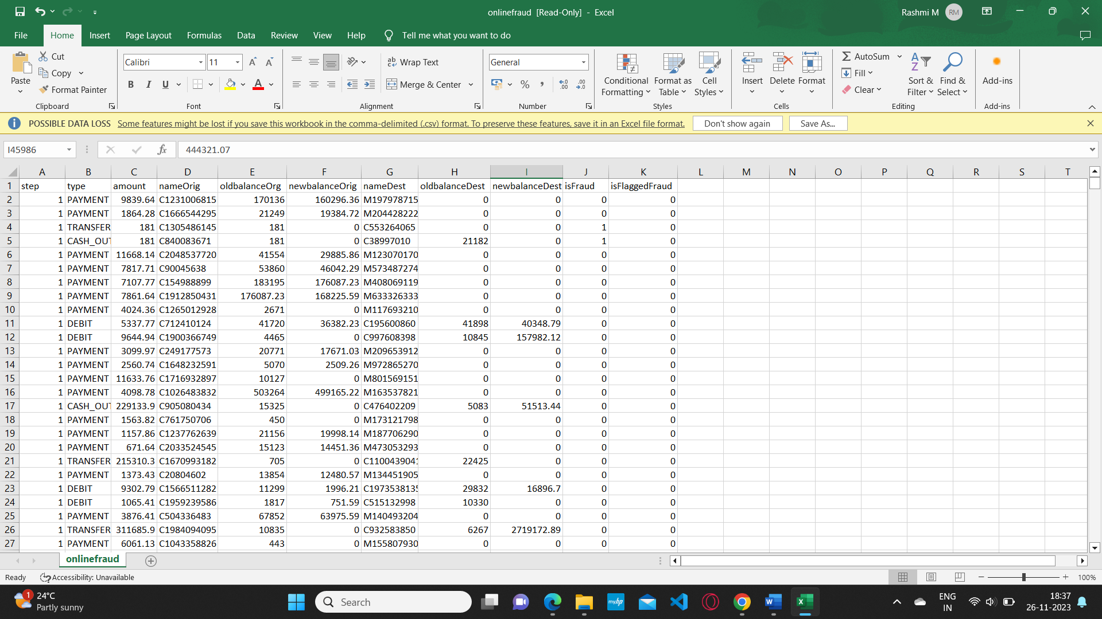

**Figure3:** online payment fraud detection dataset

**6.2 CODE**

#importing Libraries

import pandas as pd

import numpy as np

import matplotlib.pyplot as plt

import seaborn as sns

import random

#loading the data

data=pd.read_csv("C:\\Users\\RashmiM\\Downloads\\PS_20174392719_1491204439457_log.csv.zip")

data

#Print the first five rows of the dataset

data.head()

#Print the info of the dataset

data.info()

#Print the statistical format

data.describe()

#find the missing values

data.isnull().sum()

#dropping the duplicate values

data.drop_duplicates()

#data visualizations to know the type of payments counts

fig = plt.figure(figsize =(10, 7))

data['type'].value_counts(normalize=True).plot(kind='bar')

plt.show()

#to know the percentage of fraud transactions and no fraud transactions

print("No Frauds Percentage:",data['isFraud'].value_counts()[0]/len(data['isFraud'])*100)

print("Frauds Percentage:",data['isFraud'].value_counts()[1]/len(data['isFraud'])*100)

data.drop(['isFlaggedFraud','nameOrig','nameDest'], axis = 1, inplace = True)

correlationdata = data.copy()

correlationdata.drop(['type'], axis = 1, inplace = True)

fig = plt.figure(figsize =(10, 7))

sns.heatmap(correlationdata.corr(), annot = True)

plt.show()

dataf = pd.get_dummies(data = data,columns = ['type'], drop_first = True)

dataf.head()

#scaling the features

from sklearn.preprocessing import RobustScaler

rscaler = RobustScaler()

scaled_data = rscaler.fit_transform(dataf)

data_sc = pd.DataFrame(scaled_data, columns = dataf.columns)

data_sc.head()

nonfraud = dataf[dataf['isFraud']==0]

fraud = dataf[dataf['isFraud']==1]

nonfraud = nonfraud.sample(n=8300, random_state = 1)

frauddata = pd.merge(fraud,nonfraud, how = "outer")

x = frauddata.drop('isFraud', axis = 1)

y = frauddata['isFraud']

#splitting the data into test and train

from sklearn.model_selection import train_test_split

from sklearn.metrics import accuracy_score

x_train,x_test,y_train,y_test = train_test_split(x,y,train_size = 0.3, random_state = 42)

#LogisticRegression

from sklearn.linear_model import LogisticRegression

logreg = LogisticRegression()

logreg.fit(x_train,y_train)

y_pred = logreg.predict(x_test)

#DecisionTreeClassifier

from sklearn.tree import DecisionTreeClassifier

dt = DecisionTreeClassifier()

dt.fit(x_train,y_train)

y_pred_dt = dt.predict(x_test)

#RandomForestClassifier

from sklearn.ensemble import RandomForestClassifier

rf = RandomForestClassifier()

rf.fit(x_train,y_train)

y_pred_rf = rf.predict(x_test)

#GradientBoosting

from sklearn.ensemble import GradientBoostingClassifier

gb = GradientBoostingClassifier()

gb.fit(x_train,y_train)

y_pred_gb = gb.predict(x_test)

#classification report of logistic regression

from sklearn.metrics import accuracy_score, classification_report

print("Logistic Regression classification report: \n\n" ,classification_report(y_test,y_pred))

#classification report of decision tree

print("Decision Tree classification report: \n\n" ,classification_report(y_test,y_pred_dt))

#classification report of random forest

print("Random Forest classification report: \n\n" ,classification_report(y_test,y_pred_rf))

#classification report of gradient boosting

print("Gradient Boosting classification report: \n\n" ,classification_report(y_test,y_pred_gb))

#Printing the Accuracy Score

print("Logistic Regression Accuracy Score:", accuracy_score(y_test,y_pred))

print("Decision Tree Accuracy Score: ", accuracy_score(y_test,y_pred_dt))

print("Random Forest Accuracy Score: ", accuracy_score(y_test,y_pred_rf))

print("Gradient Boosting Accuracy Score: ", accuracy_score(y_test, y_pred_gb)

1. **RESULTS**
2. **Data Visualization**

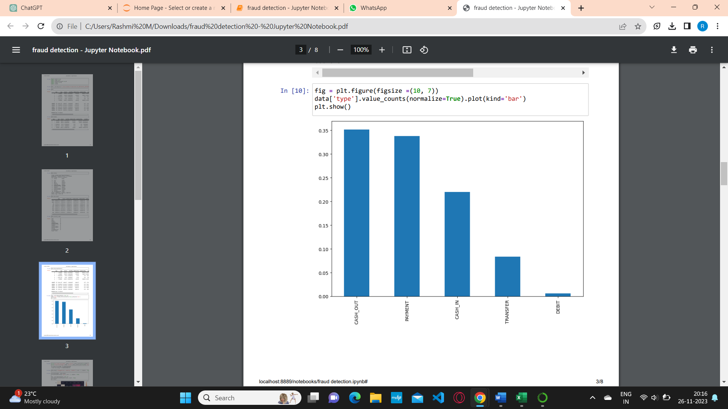

**Figure4:** shows the count of type of transaction

1. **Correlation Matrix**

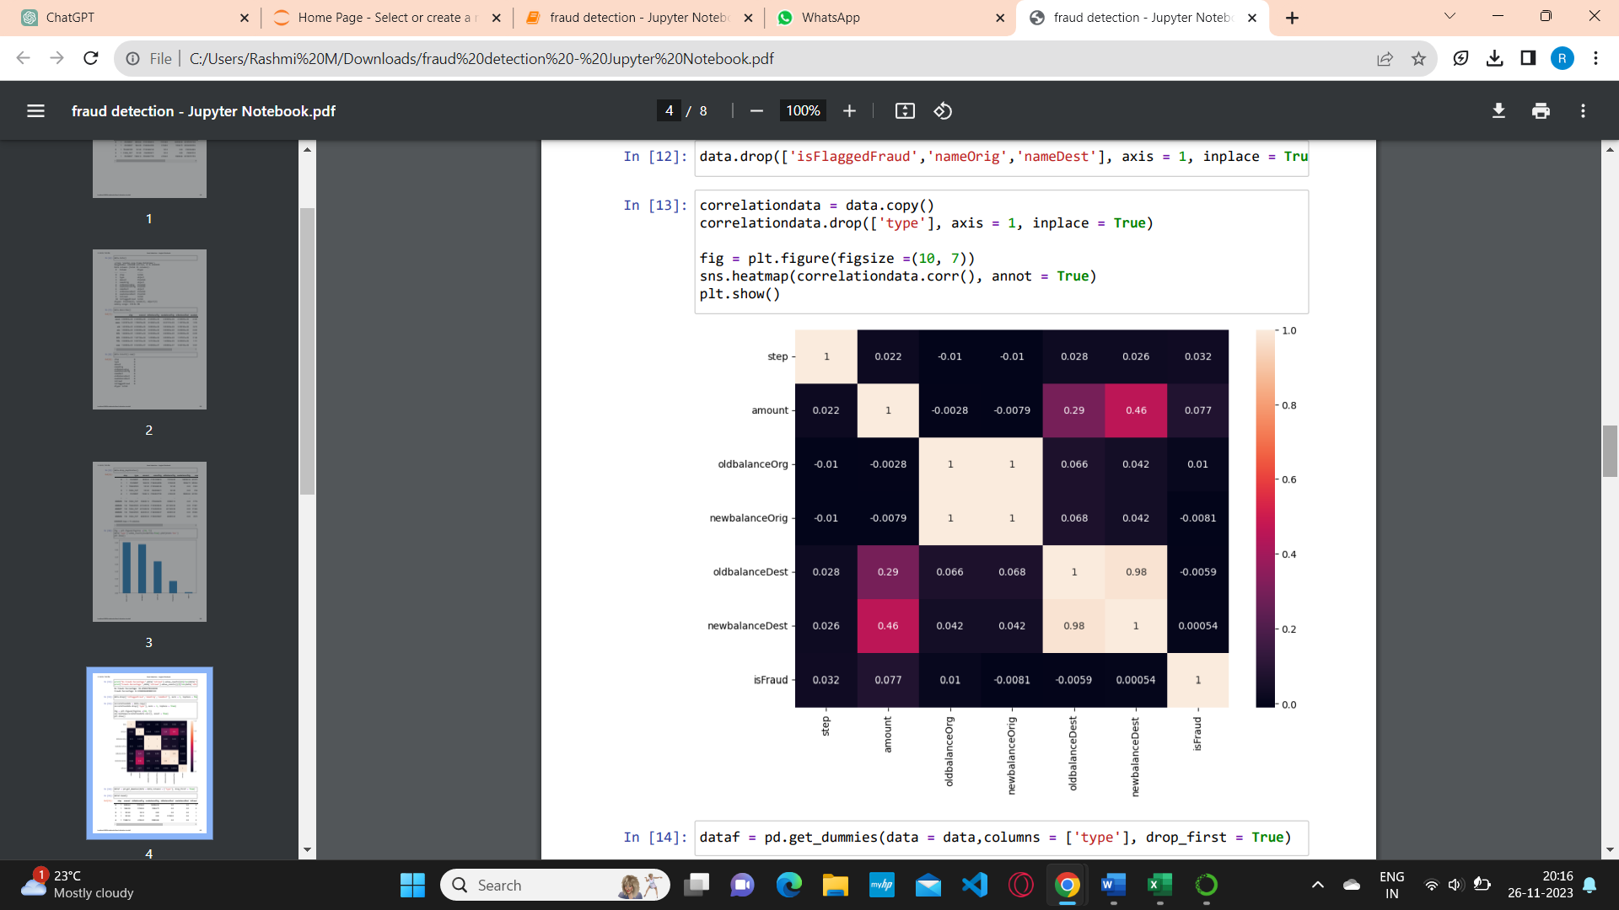

**Figure5:** Correlation Graph

1. **Accuracy of the Algorithms:**

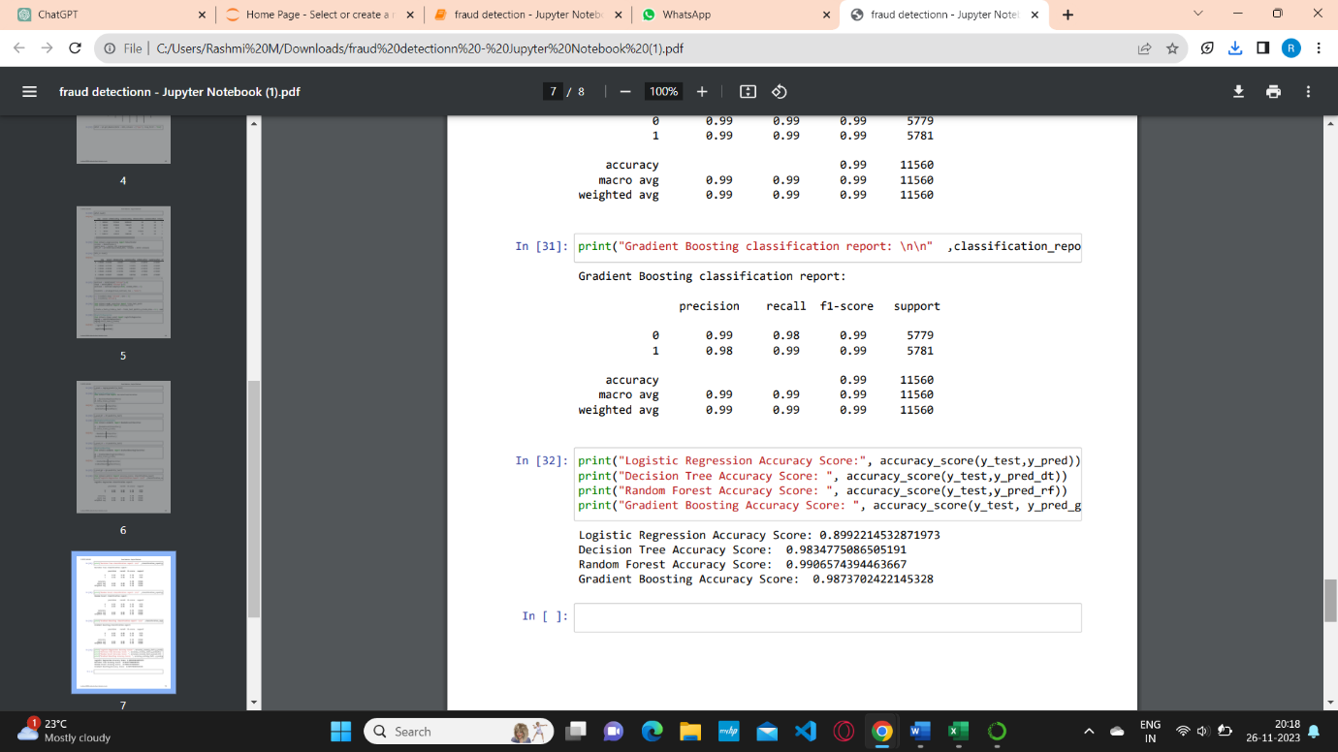

**Figure6:** Accuracy Score

1. **Percentage of fraud and not fraud:**

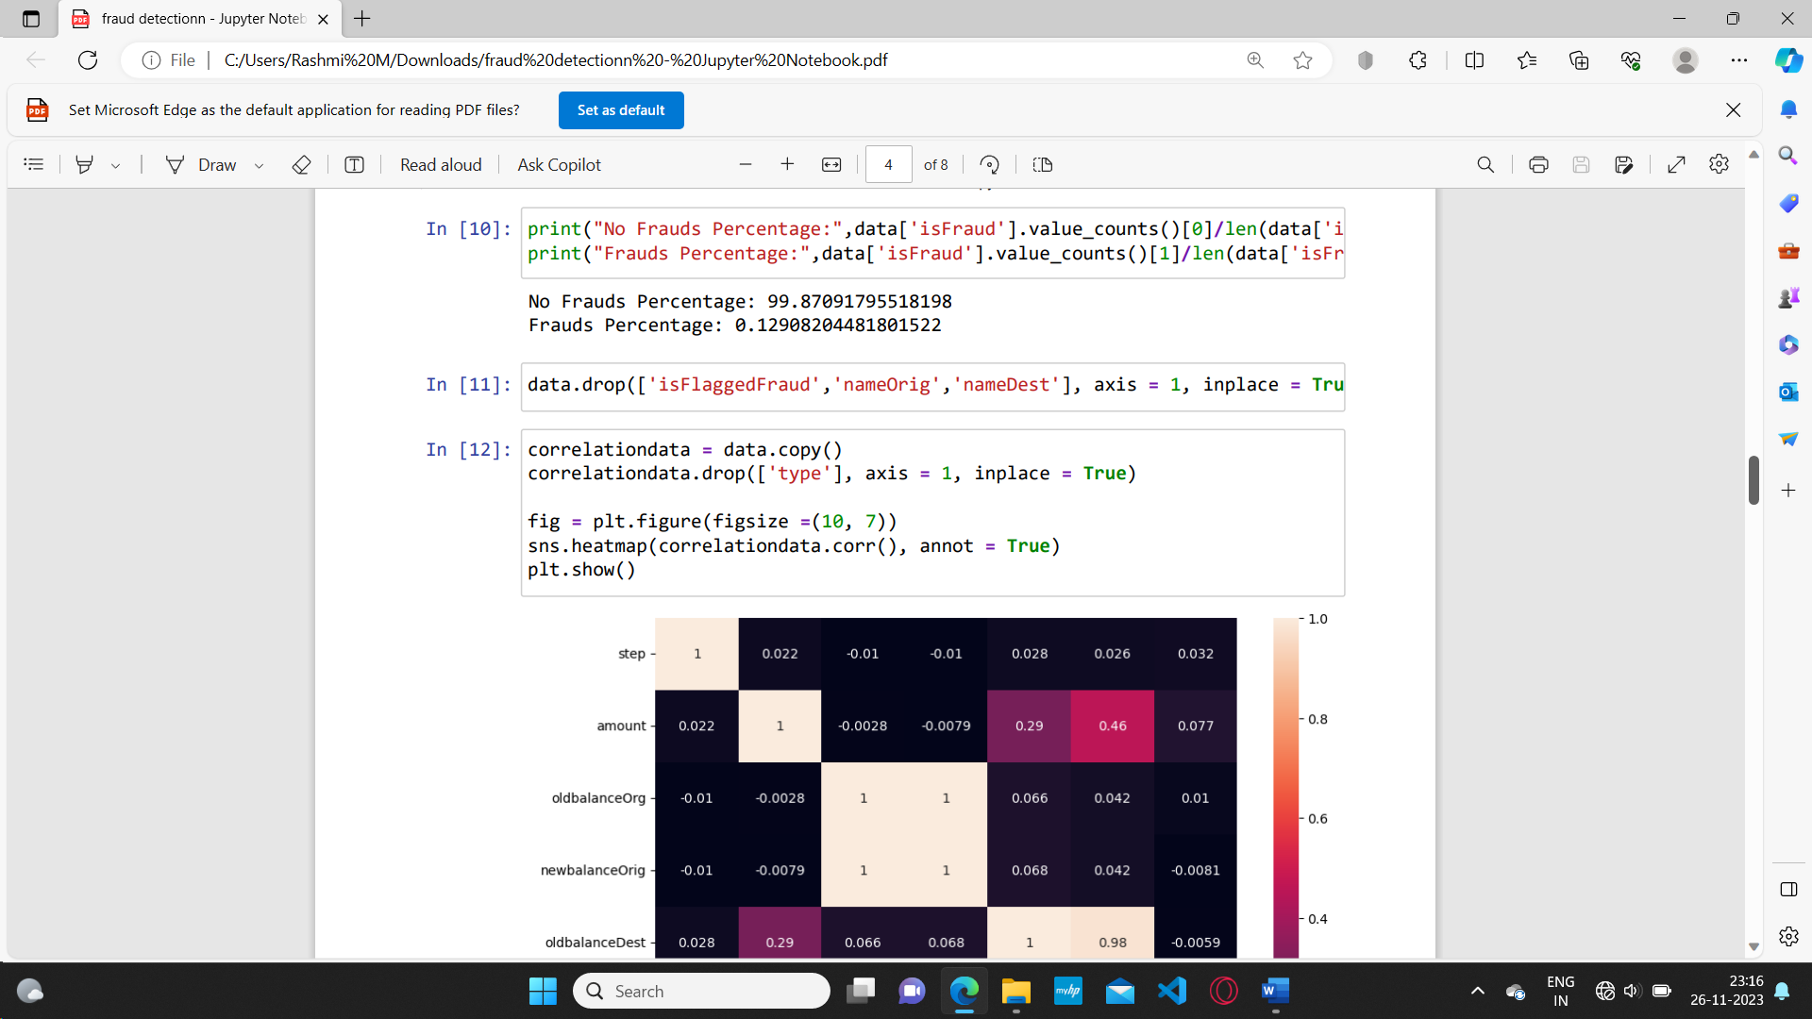

**Figure7:** Predicted Fraud and not Fraud Transaction Percentage

1. **APPLICATIONS**

The application of online payment fraud detection using machine learning algorithms has several real-world implications across various industries. Here are some notable applications:

1. **Financial Institutions:**

* **Banks and Credit Companies:** Detecting fraudulent transactions in real-time helps prevent financial losses and protect customers.
* **Payment Processors:** Ensuring the security of online transactions is crucial for payment processing companies.

1. **E-commerce:**

* **Online Retailers:** Protecting against payment fraud is vital for e-commerce platforms to maintain customer trust and safeguard their revenue.
* **Digital Goods and Service Providers:** Platforms that sell digital goods or services are susceptible to fraud, and detection mechanisms are essential.

1. **Fintech Companies:**

* **Mobile Payment Providers:** Fraud detection is critical for companies offering mobile payment solutions to ensure secure transactions.
* **Peer-to-Peer Lending Platforms:** Preventing fraudulent activities in financial transactions is crucial for peer-to-peer lending platforms.

1. **Government Agencies:**

* **Tax and Revenue Services:** Detecting fraudulent transactions related to taxes and revenue collection is important for government agencies.
* **Social Benefit Programs:** Fraud detection in online transactions related to social benefit programs can help ensure proper distribution of funds.

1. **Healthcare:**

* **Health Insurance Providers:** Detecting fraudulent claims in healthcare transactions helps control costs and maintain the integrity of the insurance system.

1. **Travel and Hospitality:**

* **Online Travel Agencies:** Fraud detection is important in the travel industry to prevent unauthorized transactions and protect customer information.

1. **Gaming Industry:**

* **Digital Gaming Platforms:** Online gaming platforms may face fraud in transactions related to in-game purchases and virtual goods.

1. **Telecommunications:**

* **Mobile Service Providers:** Fraud detection in online transactions related to mobile services helps protect against unauthorized usage and billing fraud.

1. **Educational Institutions:**

* **Online Course Platforms:** Preventing fraudulent transactions in online course platforms helps protect the revenue of educational institutions.

1. **Insurtech:**

* **Insurance Technology Companies:** Detecting fraud in insurance transactions is crucial for Insurtech companies to maintain profitability and trust.

Implementing effective fraud detection systems in these applications not only safeguards financial interests but also contributes to the overall security and trust in online transactions. As technology evolves, the need for robust fraud detection mechanisms becomes increasingly important to stay ahead of evolving fraud tactics.

**8.1** **APPLICATIONS OF AI/ML**

Artificial Intelligence (AI) and Machine Learning (ML) are two of the most promising and rapidly developing technologies today, with numerous potential applications across various fields. Here are some examples of how AI and ML are being applied:

* **Healthcare:** AI and ML can be used in healthcare to diagnose diseases, analyse medical images and scans, and personalize treatments based on patient data. For example, ML algorithms can be trained to detect cancer in medical images with high accuracy, and AI-powered chatbots can assist patients in diagnosing and treating common illnesses.
* **Finance:** AI and ML can be used in finance to detect fraud, analyse market trends, and improve risk management. For example, ML algorithms can analyse large amounts of financial data to detect fraudulent transactions, and AI-powered chatbots can assist customers in managing their finances and investments.
* **Manufacturing:** AI and ML can be used in manufacturing to optimize processes, reduce costs, and improve quality control. For example, ML algorithms can analyse production data to identify inefficiencies and optimize production processes, and AI-powered robots can be used for repetitive and dangerous tasks.
* **Transportation:** AI and ML can be used in transportation to improve safety, reduce congestion, and optimize routes. For example, ML algorithms can analyse traffic data to predict and mitigate congestion, and AI-powered vehicles can assist in autonomous driving.

1. **TRAINING EXPERIENCE**

Hands-on Learning: My training program was designed to provide hands-on experience with AI and ML tools and technologies. I was given the opportunity to work on real-world projects and problems, which helped me develop practical skills and apply theoretical concepts.

* **Mentorship:** I was fortunate to have a mentor who was an experienced AI and ML professional. My mentor provided guidance, feedback, and support throughout my training program, which was invaluable in my learning journey.
* **Collaboration:** One of the most exciting aspects of my training program was the opportunity to work with a team of professionals from different backgrounds. We collaborated on projects and shared ideas, which helped me develop my communication and collaboration skills.
* **Exposure to Industry Trends:** I was able to stay up-to-date with the latest industry trends and developments in AI and ML through various workshops, seminars, and conferences. This helped me gain a broader perspective on the field and prepare for future challenges.
* **Use of Industry-standard Tools and Technologies:** During my training, I had the opportunity to work with industry-standard tools and technologies such as Python, TensorFlow, Keras, and Scikit-Learn. This allowed me to gain practical skills that are in demand in the industry.
* **Importance of Data Preparation:** One of the most important lessons I learned during my training was the critical role of data preparation in the success of AI and ML projects. I learned how to collect, clean, and preprocess data to make it suitable for training models.
* **Iterative Process:** I also learned that developing an AI or ML model is an iterative process that requires a lot of experimentation and tweaking. It is essential to have a feedback loop that allows for continuous improvement of the model.

1. **OBSERVATIONS:**

During my on-job training on Artificial Intelligence (AI) and Machine Learning (ML), I was able to observe several important things. Here are my observations:

* **Importance of Data:** The success of AI and ML models heavily depends on the quality and quantity of data available for training. Without the right data, it is difficult to build accurate and effective models. Therefore, data preparation and cleaning is a critical step in the ML pipeline.
* **Diversity of Applications:** AI and ML can be applied in various domains, from healthcare to finance, from retail to transportation. The applications are diverse and endless, and the potential impact of AI and ML on society is enormous.
* **Iterative Process:** Developing an AI or ML model is an iterative process that requires a lot of experimentation and tweaking. It is essential to have a feedback loop that allows for continuous improvement of the model.
* **Algorithm Selection:** There is no one-size-fits-all algorithm for ML. The choice of algorithm depends on the specific problem being solved, the type of data available, and the desired output. It is crucial to have a good understanding of different algorithms and their strengths and weaknesses.
* **Ethics and Bias:** The development of AI and ML models raises ethical and bias concerns. Biases can be introduced through the data used to train the model, and it is crucial to ensure that the model is fair and unbiased.
* **Importance of Visualization:** Visualization is a powerful tool for exploring and understanding data. It can help identify patterns and trends in the data, which can be used to improve the model's performance.
* **Role of Domain Experts:** Domain experts play a critical role in the development of AI and ML models. They have a deep understanding of the problem and the data, which can help identify the right features and improve the model's performance.
* **Importance of Communication:** Effective communication is critical when working with cross-functional teams. Clear communication of goals, expectations, and results is essential for success.

1. **KEY LEARNINGS**

During the training program, I learned a range of skills and concepts related to Artificial Intelligence and Machine Learning. Some of the key skills that I acquired are:

* **Understanding of Artificial Intelligence:** I gained a comprehensive understanding of Artificial Intelligence, including the various subfields such as Machine Learning, Deep Learning, and Natural Language Processing.
* **Machine Learning Concepts and Algorithms:** I learned about various Machine Learning concepts and algorithms, including Supervised and Unsupervised Learning, Logistic Regression, Decision Trees, Random Forests, Support Vector Machines, and K-Nearest Neighbours.
* **Deep Learning and Neural Networks:** I gained a bit knowledge on Deep Learning and Neural Networks, including Convolutional Neural Networks and Recurrent Neural Networks.
* **Programming Skills:** I developed strong programming skills in Python, including libraries such as Numpy, Pandas, Seaborn and Matplotlib.
* **Data Collection:** I gained knowledge on exploring vast datasets through various public sites.
* **Data Preprocessing and Analysis:** I learned various techniques for data preprocessing and analysis, including Data Cleaning, Data Wrangling, and Exploratory Data Analysis.

**11.1** **CHALLENGES**

* This project on online payment fraud detection using machine learning faces several challenges. The foremost obstacle lies in handling imbalanced datasets, where fraudulent transactions are infrequent, leading to biased models.
* The dynamic nature of fraud poses an ongoing challenge, demanding constant model adaptation. Feature engineering complexities, the presence of unlabelled data, and the risk of adversarial attacks add layers of difficulty.
* Striking a balance between real-time processing demands and model interpretability is a critical challenge, along with addressing privacy concerns and ensuring regulatory compliance.
* Successful navigation of these challenges requires a multidisciplinary collaboration, continuous improvement, and an adaptive approach to stay ahead in the evolving landscape of online fraud detection.

1. **CONCLUSION**

The online payment fraud detection project was a valuable learning experience that allowed me to apply my knowledge of data analytics and machine learning in a real-world setting. I gained hands-on experience with various data preprocessing techniques, machine learning algorithms, and visualization tools. I also learned how to interpret and present the results of the analysis to stakeholders and predicted a accuracy of 99% for Random Forest Algorithm. Overall, the project helped me develop practical skills that are in demand in the data analytics industry.

In conclusion, the landscape of online payment fraud detection through machine learning demands a dynamic and adaptive approach. As fraud tactics evolve, continuous monitoring and model updates are imperative. Challenges such as imbalanced datasets and adversarial attacks require innovative solutions like resampling techniques and adversarial training. Real-time processing, interpretability, privacy considerations, regulatory compliance, and multidisciplinary collaboration are pivotal for success. The journey towards effective fraud detection is ongoing, necessitating continuous research and development to stay ahead in the ever-changing realm of online transactions.

Overall, my Internship Training experience on Artificial Intelligence and Machine Learning was extremely valuable. I gained a solid understanding of the fundamental concepts and techniques in the field, and developed strong programming and data analysis skills. The hands-on projects that I completed during the training gave me a real-world experience of implementing machine learning algorithms on real datasets. I am confident that the skills and knowledge that I acquired during the training will be invaluable in my future career as a data scientist or machine learning engineer.